DYNAMIC TAEKWONDO WORKOUTS
Abstract (Özet)
Introduction and Aim: The purpose of this study was …
Materials and Methods: To investigate the effects of a 6-week dynamic training…
Result: It was determined that the differences between pre-test and post-test…
Conclusion: The Tabata protocol supports…
Keywords: Keyword1, Keyword2, Keyword3, Keyword4, Keyword5

INTRODUCTION (GİRİŞ)
Training is a set of activities… that are performed systematically and regularly in order to improve athletic performance. The goal here is to be able to complete a particular activity as quickly as possible, or to increase the intensity, volume, or scope of the skills to be performed within a given period.

MATERIALS AND METHODS (GEREÇ VE YÖNTEMLER)
Research Pattern (Second Level Headings)
The study was designed as a pre-test and post-test experimental study with control group (randomized controlled trial).
Participants
The study was conducted with 25 randomly selected athletes who volunteered to participate in the study.
Ethical Suitability
All athletes were informed about the study and were explained about the possible benefits and risks of the research. After expression, all athletes were given a written informed consent from which was prepared according to the Declaration of Helsinki. The study was conducted in compliance with the ethical principles of the European Convention and the Helsinki Declaration (ethics principles regarding human experimentation). It was confirmed by the Bioethics Commission of the Ordu University (no: ******-****.***.**).
Procedure
Both the experimental and control group athletes participated in their routine training programs...
Body Composition Measurements (Third Level Headings)
To determine the body composition of the athletes, their height, body weight, body mass index, body fat percentage, and body fat mass values were determined…
Determination of balance performance (fourth level headings)
The dynamic and static balance performance with eyes open and closed were determined using a balance system (Figure 1).

[Figure 1 near here]

Implementation of the test (fifth level headings). The athletes could perform 2 trials before the actual implementation for them to adapt to the balance system…

RESULTS (BULGULAR)
The athletes' body composition values and balance (eyes closed-open, dynamic-static) and strength (hand grip, back, leg) performance results were determined with in-group and inter-group measurements.

[Table 1 near here]

DISCUSSION (TARTIŞMA)
The data collected for the control and experimental group athletes before the experimental stage showed that there was no significant difference between the groups in terms of body composition, balance, and strength, that the control and experimental group athletes had similar body compositions and balance and strength performances (Table 2-7) …

CONCLUSION (SONUÇ)
The improvement of an athletic skill or performance occurs rapidly in novice athletes, but it is much slower in elite athletes…

REFERANCES (KAYNAKLAR)
Ölmez, C. (2020). Development of performance evaluation scale. The Journal of International Anatolia Sport Science, 10(1), 1–6. https://doi.org/10.5552/se.2020.20099
Ölmez, C.; Üçüncü, N; Aksoy, E., Bianco, A., Mancuso, E. P., & Patti, A. (in press). Development of taekwondo performance evaluation scale. The Journal of International Anatolia Sport Science. https://doi.org/10.1038/30515
Cevahir, J. (2005). International Anatolia Sport Science. Ankara: Scene Medicine.
Aksoy, E. (Ed.). (2020). Development of kyorugi performance evaluation scale. Ordu: Anatolia Sport.
Olmez, C. (2021). Taekwondo training in schools [Unpublished master’s thesis]. Ordu University, Ordu.

APPENDICES (EKLER)
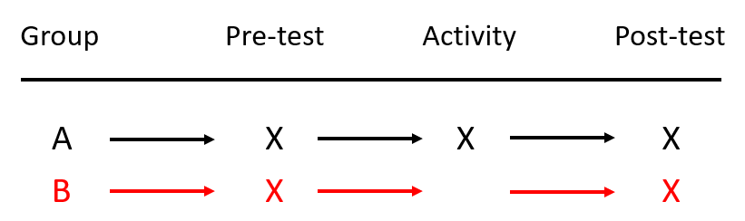
Figure 1. Research pattern

Table 1. Body composition values of the athletes
 |  | mean | Sd. | p
Body Weight (kg) | EG (n=12) | 70,53 | 5,60 | 0,663
 | CG (n=13) | 72,42 | 6,62
Height (cm) | EG (n=12) | 174,58 | 5,04 | 0,219
 | CG (n=13) | 177,31 | 5,68
 | CG (n=13) | 8,59 | 3,38
BMI = Body Mass Index; *p<0,05

